Chapter 13, Solution 71.

In the autotransformer circuit in Fig. 13.134, show that

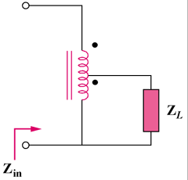

Figure 13.134
For Prob. 13.71.

Solution

Z_{in} = V₁/I₁

But V₁I₁ = V₂I₂, or V₂ = I₂Z_{L} and I₁/I₂ = N₂/(N₁ + N₂)

Hence V₁ = V₂I₂/I₁ = Z_{L}(I₂/I₁)I₂ = Z_{L}(I₂/I₁)²I₁

V₁/I₁ = Z_{L}[(N₁ + N₂)/N₂] ²

Z_{in} = [1 + (N₁/N₂)] ²Z_{L}

